Session 2

- Create a Python script called playlist_stats.py that takes a list of daily Spotify song play counts (e.g., [120, 135, 150, 200, 120, 90, 200]) and calculates the mean (average) number of plays.

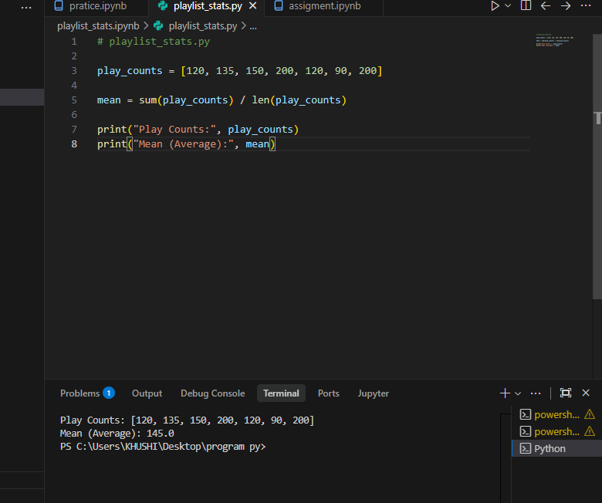
2. Given the following array of delivery times (in minutes) for Zomato orders: [30, 25, 40, 35, 30, 45, 30], write code to find the median delivery time and print it.
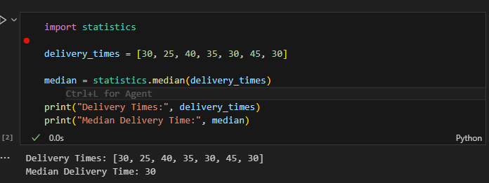

3.Write a function most_common_rating(ratings) that takes a list of Flipkart product ratings (e.g., [5, 4, 4, 3, 5, 4, 2, 4]) and returns the mode (most frequent rating).
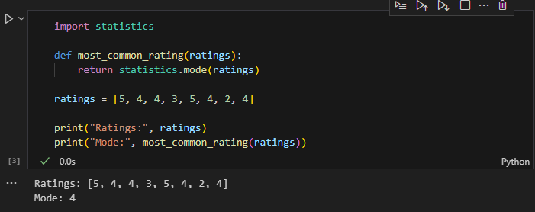

4. Given three lists representing YouTube video views for three different channels, compare the mean, median, and mode for each channel, and decide which channel's data is most affected by outliers.<br><br><em><strong>Hint:</strong> Try using one list with a very high value (e.g., [100, 120, 110, 105, 5000]) to see the effect on mean vs median.</em>
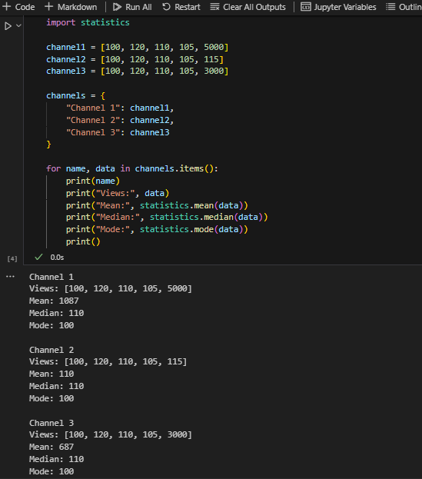
5. Pick any real dataset from Kaggle or UCI (e.g., IPL player runs, Swiggy restaurant ratings, or movie box office collections), load it using pandas, and display the mean, median, and mode for one numeric column of your choice.
